Sarnia Hockey Association 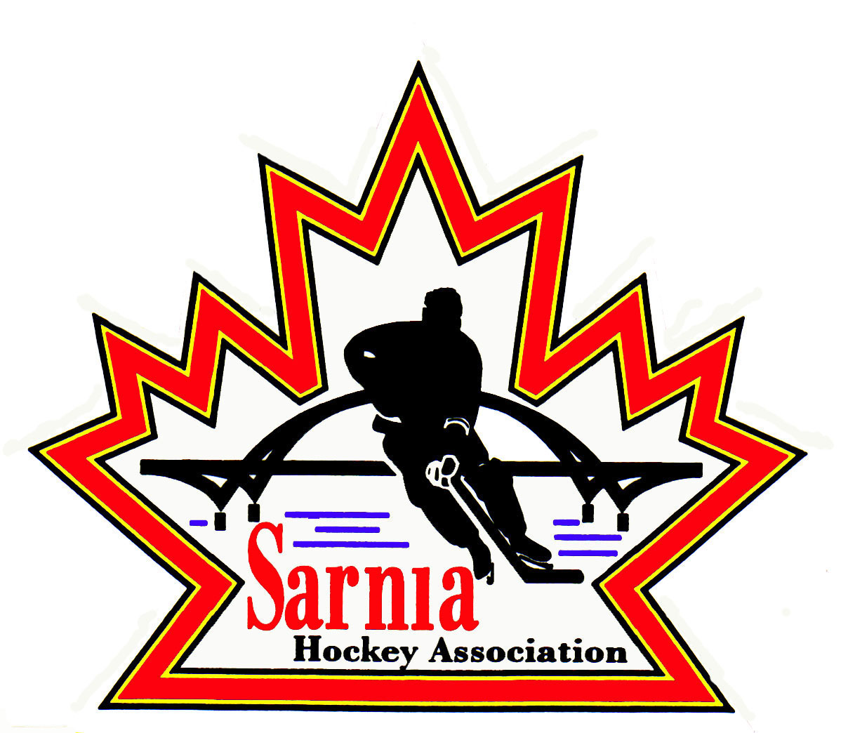

Minutes | Date MAY 17, 2023 | time 7:00 pm

Meeting called by | Paul Walsh, Chairperson
Type of meeting | Regular
Secretary | Kelly Lane, Secretary

Welcome | Paul Walsh, Chair welcomed everyone and called the meeting to order at 7:04 pm.

ATTENDANCE | Tom Babcock, Andrew Beasley, Jacquie Beasley, Jerry Bernardo, Emily Brown, Harry Chadwick, Darren Chevalier, Justin Day, Joe DiCocco, Chuck Ewart, Jeff Fogal, Pat Forbes, Terry Gray, Kelly Lane, Cris LaPointe, Don McGugan, John Mellor, Kyle Mellor, Ted Pendle, David Penner, Lesley Smith-Taylor, Kevin Taylor, Tim Turner, Barb Walsh, Paul Walsh  Regrets: Ian Dunn, Paul Douglass, Linda Lauzon, Wayne Scarrow

ACCEPTANCE OF MINUTES | MOTION #230517-001  “That the Minutes from May 2, 2023 be accepted as presented.” (Pendle/J. Mellor)  Carried with amendments

TREASURER’S REPORT | No Report  2023/2024 BUDGET:  - Last year ice bills from the City of Sarnia were only received twice. June to September registration was banked and our interest increased.  - Fundraising bingos are held twice monthly. We budgeted $10,000 but received a record amount of $23,600.  - The Chair thanked the budget committee members for their assistance. All of our budget items are based on the previous year’s actuals.  - For those board members that submitted budgets, everyone got what they asked for in the new budget.  - We are working with a $1.2 million operating budget. Largest item is ice cost.  - We were able to determine that we could leave registration at last year’s amount with no increases.  - We did implement a late fee of $250 which will take effect August 1. Getting players registered early helps directors determine number of rec teams per division. We have historically seen that having a late fee is a deterrent to late registrants.  - For new families coming into the Association, we don’t penalize them with a late fee. U16-21 also doesn’t have a late fee due to a large number of players at Junior camps and they can’t make commitment until those camps are over.  - Alliance fee increase has been accommodated into the budget.  MOTION #230517-002  “That the 2023/2024 budget be accepted as presented.” (Pendle/L.Smith-Taylor)  Carried

BILLS TO BE PAID | MOTION #230517-003  “That the bill be paid as presented.” (Pendle/Ewart)  Carried
  Recipient | Expense | Amount
  Scott Jones | Coach mentoring | $4,650.00

REGISTRATION DIRECTOR | MOTION #230517-004  “That SHA open registration on June 1 and close July 31. Anyone registering after August 1 will be subject to a late fee. All payments to be made by September 1.” (L. Smith-Taylor/Pendle)  Carried  - We will proceed with the enhanced Facebook advertising for registration. Emily Brown to work with the website director to set this up.  - Rec jersey order has to be submitted by early August.  - Rep players with spring tryouts have to register by June 30. Rep rosters have to be in by July 31.  With OHF changing rules, rep teams can have exhibition games and 1 tournament by the end of September this year.  - Volunteer registration to be opened June 1 so rep volunteers/coaches/managers and all bench staff can be rostered. There is no cost this is an administrative requirement.  - Players participating in fall tryouts (U8, U9, U18) don’t have to register by June 30.  - Volunteer registration is a data collection that volunteers sign off on Rowan’s Law, so we are in compliance.

REP VICE CHAIR | TRY OUTS:  - 314 players registered for tryouts.  - We have established rosters for 14 teams. One team is 2 goalies short. We rostered 236 players.  - We had a couple of complaints at a few age groups. One about a coach error – an anonymous complaint about a team which turned about to be an error. One coach cut players on the first night which we had to reverse. Overwhelmingly it was a positive process. 98.7% of those that tried out did not have concerns with the process.  - This year we brought in Scott Jones to do a mentorship with the coaches. He spent 1 ½ hours each time and provided advice to the coaches as they ran through their tryouts. Rep Vice Chair and MD Director attended some of the tryouts.  - From a coach’s perspective it went well.

ICE DIRECTOR’S REPORT | - Invoices have been sent to the teams that owe for referees and extra ice for tryouts  - All blackout dates for 2023-2024 that are currently known have been forwarded to the City.  - One team has sent in their tournament dates and Ice Director is requesting Rep Directors send a reminder to everyone to get those in before the middle of June.  - Scheduling of the games will probably start sometime in July.  - If teams can provide their preference for double header games to avoid extra travel, that would be great.  - In the next couple weeks, Ice Scheduler will start to enter practice/game ice slots on the website.

REC VICE CHAIR | - In lieu of a Vice Chair of Registration, it is proposed that we establish an Adhoc Recreation League Steering Committee to provide guidance for the new directors and a few members to manage the complaint process. Key jobs will be completed by the group. This will be a collaborative effort to hopefully recruit someone for that role. It’s an important role in the Association.  MOTION #230517-005  “That a Recreation Steering Committee, appointed by the Chair for the 2023/2024 season be established.” (K. Taylor/Brown)  Carried  - We should have one person to oversee the committee, 3 directors as voting members and have the First Vice Chair act as chair of the sub committee.  - The following board members have offered to be part of this committee: Jeff Fogal, Joseph DiCocco, Emily Brown and Pat Forbes.  OHF PROGRAM SHIFT U6-U9:  - OHF wants to provide a more “a la carte” program for U6-U9 that can provide players with more than the average ice time per week to assist in their development.  - Historically our U6 has been 1 hour per week and U7 to U9 has been two ice times per week.  - U8/U9 stays the same.  - Players/parents will have the choice to do a little bit of hockey or a lot of hockey.  - The concept is to call U6 “Foundations.”  - U7 players have the option to go to two ice times per week.  - Players can register for Foundations as a 4, 5, 6, 7 or 8 year old or get into U7 and do both.  - Challenge is how to effectively register for this. U6 to U9 is $350. U7 (5 and 6 year old’s) is $650 and U9 (7-9 year old’s) is $650.  - We will need to articulate this change on our website as it is a significant structure change.  - U6 (4/5 years old’s) - we will likely see the 5 year old’s move to U7. A U9 first year player can now go to U6 if they need to.  - Organization will be the key to help keep same aged kids somewhat together on a team.  - Our ice allocation doesn’t change, but we do have a 7 am time slot we can use if we need to.  - U7 can go to a shared practice as well to be more efficient with our ice availability.  - We would be bringing in more revenue which would cover off any extra ice.  - We will have parameters on registration numbers for each division.  - HCR is a problem and needs to have a work around. We are the only Association doing this at this point. A lot of extra work for registrars as they have to create packages.  - We need to remember that we were the first Association that did the cross-ice program, and it really benefitted our players.  - This is what the membership wants as per OHF surveys and a good example of bottom-up leadership.  - Foundations will be available for players aged 4-8. We have room for 140. In past years we have only had just over 100 so there is room to grow. U7 will likely grow with more U5 aged players. Co-ordination will be the key.  - We will monitor wait lists in each age slot.  - We haven’t maxed out numbers in U6-U9 in last few years.  - For the Select Program for U7 and U9, no player will be left behind for Select – every player must have a position as per the Alliance.  BUDGETED ALLIANCE CHAMPIONSHIPS  - SHA hosted the U8 MD Jamboree with 8 teams participating and it was a success.  - We learned lessons i.e., book 1 hour of ice and not 45 minutes and not to have the event on Easter weekend.  - We had a deficit of $600 on the event. It would have been collected for registration for our SHA U8 team, but we did not have them pay as they provided all of the volunteers. It was in the budget.  - U7 Jamboree is available to host, and it can be run the same way. Ice Scheduler was asked to see if we can get Pat Stapleton Arena to remain open for an additional week. We would expand our Cross ice to include both events on April 6-7, 2024.  - Normally have 15 teams. The Sarnia Sting playoff run impacted us this year. We ended up with 13 teams.  MOTION #230517-006  “That SHA host the U7 and U8 Jamboree for 2024.” (Taylor/Chadwick)  Carried  - We could see if we could get ice in Mooretown if we had to.  - Tournaments are to be at no cost to the Association that is hosting Set up expense/revenue spreadsheet and set price of tournament to be even or a slight profit.

REP EQUIPMENT DIRECTOR | - Fit nights will be scheduled so jerseys can be ordered in time for September. Planet Stitch updating their team apparel and will help with fitting.  - Players are picking their own numbers.  - AP jerseys will have selected numbers.  - U18 will not be selecting numbers nor the U8/U9 age groups that try out in the fall. We have to pre order the jerseys to have them available in the fall.

NEW BUSINESS | ALLIANCE HOCKEY AGM MOTIONS:  - There are 9 motions that the delegates that attend the Alliance AGM have to vote on.  - We need the Board to provide voting direction to the SHA delegates attending the AGM. Collectively we decide how this board wants to vote.  Motion 2023-01 – REFEREE OPERATIONS FOR AAA: No SHA vote required.  Motion 2023-02 – PLAYER MOTION AND PLAYER RETURN: Player tryouts and player return after release. Changes reflect changes to regulations. Nothing different other than housekeeping.  MOTION #230517-007  “That SHA accept Alliance Motion 2023-02.” (L. Smith-Taylor/Pendle)  Carried  Motion 2023-03 – REGULATION FEES TO THE ALLIANCE: Regulation fees to Alliance was accepted by the Alliance delegates at the Semi-Annual meeting.  MOTION #230517-008  “That SHA accept Alliance Motion 2023-03.” (Pendle/K. Taylor)  Carried  Motion 2023-04 REGULATION 13.0 BIRTH CERTIFICATES – PROOF OF AGE: Last year Alliance required birth certificates for both Rec and Rep players. This affected our rostering for Rec and Rep teams. Each Association Registrar to verify rec player birth certificates. Alliance still has to verify Rep birth certificates.  MOTION #230517-009  “That SHA accept Alliance Motion 2023-04.” (L. Smith-Taylor/Bernardo)  Carried  Motion 2023-05 – ALLIANCE OMHA MADE IN ONTARIO PLAN MOVEMENT BELOW AAA: Maximum is 3 for NRP for eligible teams 2011 birth year and older. For 2012 birth (U12) year max is 2 NRP. For 2013 birth year will only be allowed 1 and 2014 and subsequent there will be none. OMHA is phasing this out.  MOTION #230517-010  “That SHA accept Alliance Motion 2023-05.” (L. Smith-Taylor/Pendle)  Carried  Motion 2023-06 PLAYER MOVEMENT: This is a housekeeping motion that affects affiliation to junior teams. SHA has a documented policy of playing up that requires board approval for U9 and above.  MOTION #230517-011  “That SHA accept Alliance Motion #2023-06.” (Mellor/Pendle)  Carried  Motion 2023-07 CLASSIFICATION OF TEAMS: This is a housekeeping motion.  MOTION #230517-012  “That SHA accept Alliance Motion 2023-07.” (Mellor/Pendle)  Carried  Motion 2023-08 - FREEDOM OF MOVEMENT POLICY FOR AAA: No SHA vote required.  Motion 2023-09 - RESCHEDULING, CANCELLATION AND FORFEIT: Changes regarding rescheduling and costs of cancelling games.  MOTION #230517-013  “That SHA accept Alliance Motion 2023-09.” (Mellor/Babcock)  Carried  SCREENING CHECKS FOR BOARD MEMBERS:  - SHA Board Members will be notified whether they require a police check or CODF dependent upon your role on the Board.  - We did risk assessment on each position which determined whether you require police check or CODF each year.  FIRST SHIFT PROGRAM:  - Registration for this program opens June 1 and we need 10 instructors to assist.  - Looking at 3 dates in December and 3 dates in January.  - We will take 45 players.  - Need 6 on ice helpers (age 14-16).  - Trying to do it collaboratively with Sarnia Girls and Point Edward Minor Hockey.  NEXT MEETING:  - Next meeting is Tuesday, June 6, 2023, at 7:00 pm. We may be changing location due to construction at Clearwater Arena.

adjournment | MOTION #230517-014  “That the meeting be adjourned.” (Pendle)  Carried

Paul Walsh Kelly Lane
Chair Secretary

